Chapter 2: Ancient Near East
Timeline:

Civilization: | Time Period: | Location:
Sumerian | 3500-2340 BCE | Iraq
- Uruk | 4000-3100 BCE | Iraq
- Lagash | 2150 BCE | Iraq
- Neo-Sumerian | 2150-2000 BCE | Iraq
Akkadian | 2180-2340 BCE | Iraq
Babylonian | 1792-1750 BCE | Iraq
- Neo-Babylonian | 612-539 BCE | Iraq
Hittites | 1600-1200 BCE | Turkey
Assyrian | 1000-612 BCE | Iraq
Persian | 559-331 BCE | Iran

Early Bronze Age | 3000-2000 BCE
Middle Bronze Age | 2000-1600 BCE
Late Bronze Age | 1600-1200 BCE
Iron Age | 1200 BCE

Vocab Bank:

- Lamassus: Assyrian, a bull/lion/eagle combo that is a protective guardian figure.
- Fertile Crescent: Crescent shaped region between Tigris and Euphrates. Very fertile soil in an otherwise arid desert.
- City-state: a central city and its surrounding villages, which together follow the same law, have one form of government, and share languages, religious beliefs, and ways of life.
- Inanna: Sumerian goddess of sexual love, fertility, and warfare
- Ishtar/Ishtar Gate: Akkadian, Assyrian and Babylonian goddess of fertility, love, war, and sex.
- Obsidian: a deep purple and black shiny stone
- Cuneiform: earliest known systems of writing, usually "wedge-shaped" marks on clay tablets
- Stylus: for writing, a small tool for mark-making on pottery usually.
- Epic of Gilgamesh: epic Mesopotamian poem. One of the oldest pieces of literature.
- Ziggurat: in receding tiers upon a rectangular, oval, or square platform, the ziggurat was a pyramidal structure with a flat top. Sun-baked bricks made up the core of the ziggurat with facings of fired bricks on the outside.
- Inlaid: ornamental, made by embedding a different material into a void that is flush with surface.
- Register: artwork seperated in lines similar to a comic book for narrrative purposes.
- Votive Figure: an image created as a devotional offerring to a deity.
- Lyre: instrument like a harp but has a U-shaped frame
- Sistrum: is a musical instrument of the percussion family. It consists of a handle and a U-shaped metal frame, made of brass or bronze.
- Iconography: the branch of art history which studies the identification, description, and the interpretation of the content of images.
- Code of Hammurabi: First written code of laws from ancient Babylon.
- Cylinder Seal: small round cylinder, typically about one inch in length, engraved with written characters or figurative scenes or both, used to roll an impression onto wet clay.
- Stele: is a stone or wooden slab, generally taller than it is wide, erected for funerals or commemorative purposes.
- Heiratic Scale: The use of different sizes for powerful or holy figures and for ordinary people to indicate relative importance.
- Citadel: a fortress protecting a town.
- Palace Complex: Group of buildings used for living and governing by a ruler.
- Crenellations: multiple, regular, rectangular spaces in the top of the wall, where arrows or other weaponry may be shot.
- Mushhushshu: protects many of the supreme gods. Its name means 'furious snake'.
- Gold Leaf: gold that has been hammered into extremely thin sheets and is often used for gilding.
- Sumer: Cities and city-states that developed alond the rivers of Southern Mesopotamia.
Chapter Overview:
- The Anceint Near East is where almost everything began: writing, cities, organized religion, organized government, laws, agriculture, bronze casting, even the wheel.
- Large populations grew around the fertile crescent in the valleys, where city centers boomed and urbanization first began to take hold. Each group of people vied for control of the fertile land and many battles were waged as a result.
- The Ancient Near East brought about the birth of art in the service of the state and religion. Combined with writing, Mesopotamian objects give us the first systematic record of human development.
- Ancient Near Eastern buildings were created for religion, as were the ziggurats, or the state, as were the palaces. They were built of mud-brick, and were either painterd or faced with tile or stone.
  - Uruk: Realistic looking figures, acting out identifiable narratives. Intermixing of human and animal forms. Heirarchy of scale and registers are used.
  - Lagash:Guti mountain people. Many diorite images of ruler Gudea.
  - Akkadian:Deification of the King. Steles were used to denote important religious or civic sites or used as burial markers.
  - Babylonian:Well ordered state with a strict set of laws. Stele of Hammurabi. Babylonian hanging gardens.
  - Neo-Babylonian: Ishtar Gate
  - Hittites:Used stone instead of mud-brick for structures. Large uncut boulders are set in place as fortifications.
  - Assyrian: Lots of cuneiform. Shallow relief sculptures. Lamassus were 3D. Artists praised greatness of the King, ability to kill enemies, hunting, masculinity.
  - Persian: Largest empire in the world at the time. Monumental architecture, huge audience halls.
Artworks to Know:

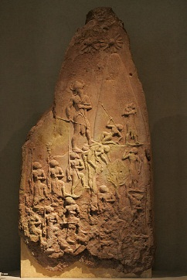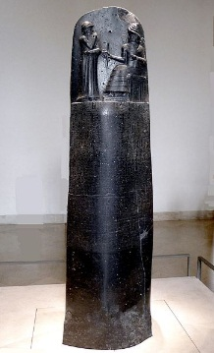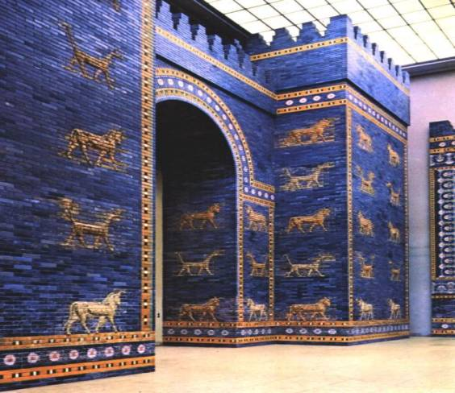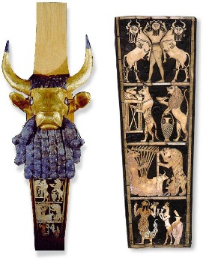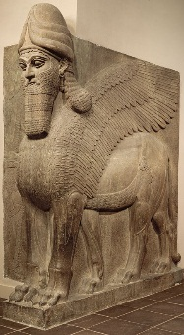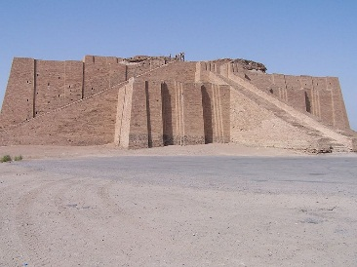
Stele of Naram-Sin  2254-2218 B.C.E  Akkadian  Pink Limestone  Defeat over the  Lullubi people.  Shows hierarchal scale  Divided in registers.  Naram-Sin wears horned helmet to symbolize divinity. Pays homage to 3 suns (God). | Stele of Hammurabi  1792-1750 B.C.E.  Babylonian  Basalt  First written code of laws. “eye for an eye”  Depicts Ham receiving code from the God Shamash. Heirarchal sclae is shown. | Ishtar Gate  575 BCE  Neo-Babylonian  Glazed Brick  Elaborate Inner-City Gate. Lapis Lazuli glazed bricks=shine.  Alternating lions, mushhushshu, and cattle. Reconstructed its  47 feet high and 100 feet wide. | Great Bull’s Head Lyre  2550-2450 BCE  Wood, Lapis, Gold, shell, bitumen  Instrument. Front panel depicts ancient funerary  Rituals. In registers is shows a heroic fig. being celebrated.  Bearded bull on front is Sun God Shamash. | Lamassu  721-705 BCE  Assyrian. Alabaster  A protective deity, often depicted with a bull or lion's body, eagle's wings, and human's head. at the opening of the city. From the front looks to be standing and from the side walking. This was done to make it seem powerful. Very tall. | Ziggurat of UR (Nanna)  21st Cent BCE  Neo-Sumerian  Mud brick  Shrine to moon God Nanna. massive step pyramid measured 210 feet in length, 150 feet in width and over 100 feet in height.

